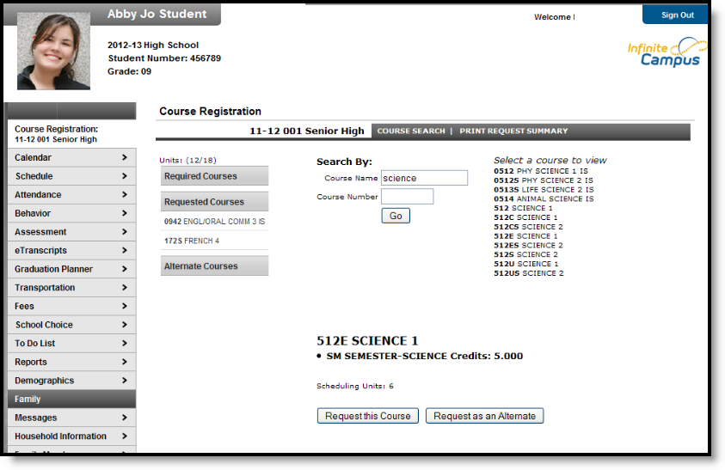
Image 1: Course Registration Tab for a Student
Course Units
Request the majority of units needed for the grade level. This is indicated by the Units mark.
- The first number (___ / 21) tells how many units the students have requested.
- The second number (21 / ____) tells how many total units are needed.
This number is based on the total number of calendar terms, period schedules and instructional class periods.
Course Registration
Logging into the Portal
- From the portal login screen, enter the Username and Password that has been assigned. The username is the student’s Student Number; the password is the student’s Birth Date in mmddyy format.
- Click the Login button. This will bring the user to the main portal page where district and school notices will be listed. If this is the first time the portal has been accessed, it is advised that users change usernames and passwords. Use the Change Account Info in the Index and follow the instructions provided.
- Click the Course Registration option from the navigation pane on the left of the screen.
- Any required requests that have been established and already inputted by school counselors and/or administrators will be listed in the Required Courses list. Students cannot change any required requests listed for them.
- Students can only request elected requests (listed under the Requested Courses list) or alternate requests.
Requesting Courses
- Click the Course Search link. A search screen will appear.
- Courses can be searched by the course name or by the course number. Enter either the Course Name (i.e., English) or Course Number (i.e., 2121).
- Click the Go button. Matching course names will appear to the right.
- Click on any course listed to view the course description.
- To request this course as part of the schedule for next year, click the Request this Course button. Courses can also be requested as alternates by clicking the Request as an Alternate button. This course would be placed on the request list. It is not a guarantee the course will be on the schedule.
- When finished requesting courses, click the Print Request Summary option to print a report of the courses that were requested.
To prevent other users from accessing the portal and changing requested courses, instead of just closing the browser, click the Log Off option in the Index. This will end the session and bring the user to the portal login screen.

